EXPERIMENT-7
DOCKER with AWS
Agenda
- Create a React Project (Take code from S3)
- Install & Create a Docker Image for the Project
- Build and Run the Docker Image
- Deploy the Docker Image to AWS Cloud

PART 1: Set up React App (on EC2)
Step 1: Launch EC2 Instance
- Go to AWS Console → EC2 → Launch an instance.
- Choose:
  - AMI: Ubuntu 22.04 LTS
  - Instance type: t2.micro
  - Key pair: Create/download one.
  - Security group: Allow ports 22 (SSH) and 3000 (React app).
- Launch the instance.
Step 2: Connect to EC2
Step 3: Install Node.js and npm
- curl -fsSL https://deb.nodesource.com/setup_16.x | sudo -E bash –
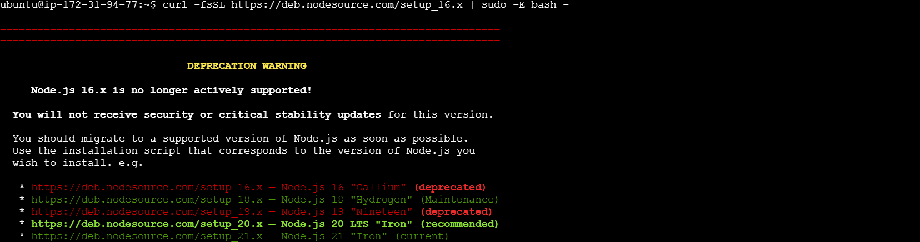
- sudo apt install -y node
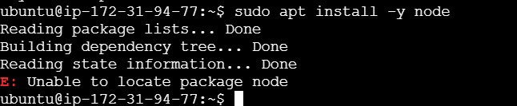
- node -v
- npm -v
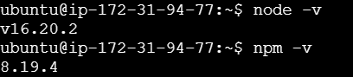
Step 4: Install git (if needed)
- sudo apt install git -y
Step 5: Create the React App
- npx create-react-app 22bd1a057a-app
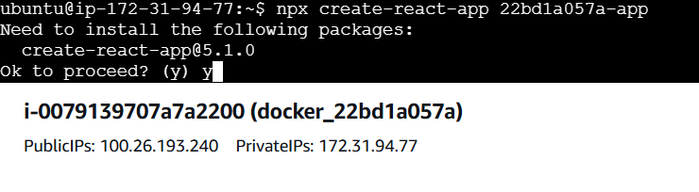
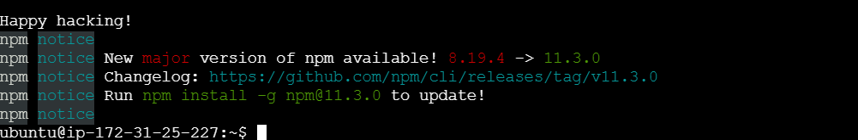
- cd 22bd1a057a-app
Step 6: Create the Component
- Inside the src/ folder, create a file welcome.js:
- nano src/welcome.js
- Paste the below code:

import React, { useState } from 'react';

const WelcomeMessage = () => {
const [name, setName] = useState('Nipeksha');
const [showMessage, setShowMessage] = useState(false);

const handleButtonClick = () => {
setShowMessage(true);
};

return (
<div>
<input
type="text"
value={name}
onChange={(e) => setName(e.target.value)}
placeholder="Enter your name"
/>
<button onClick={handleButtonClick}>Show Welcome Message</button>
{showMessage && <p>Hi "{name}!!!" Welcome to Docker Image</p>}
</div>
);
};

export default WelcomeMessage;

Step 7: Modify App.js
- nano src/App.js
- Modify like this:

import React from 'react';
import WelcomeUser from './welcome';

function App() {
return (
<div className="App">
<WelcomeUser />
</div>
);
}

export default App;
Step 8: Test React App (Optional)
- npm start
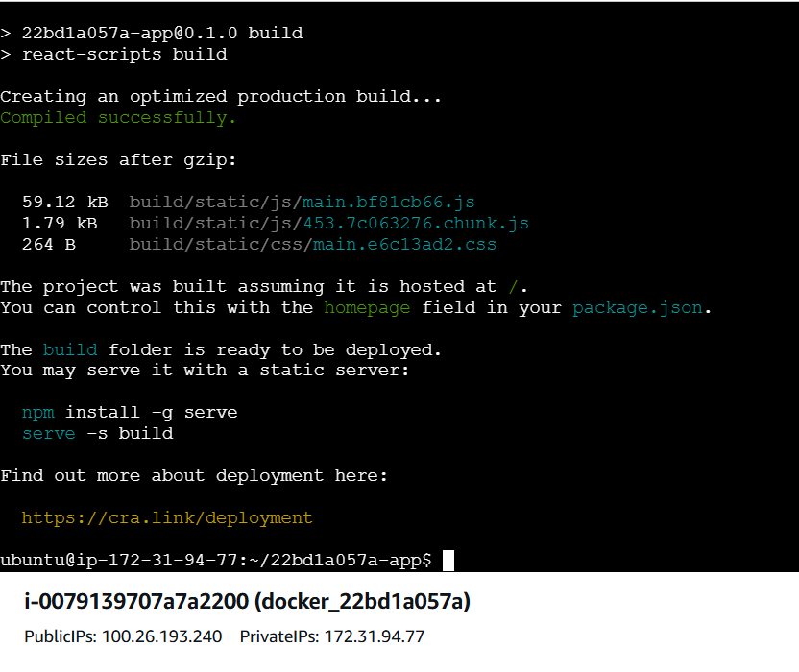

- Open browser: http://100.26.193.240:3000
- If you don't see the app, allow port 3000 in Security Group.
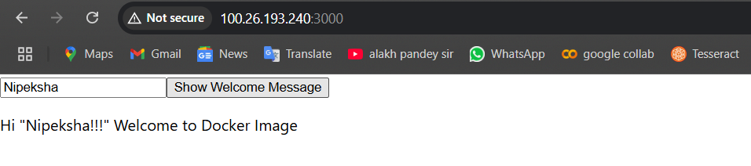

Step 9: Build React App
- npm run build
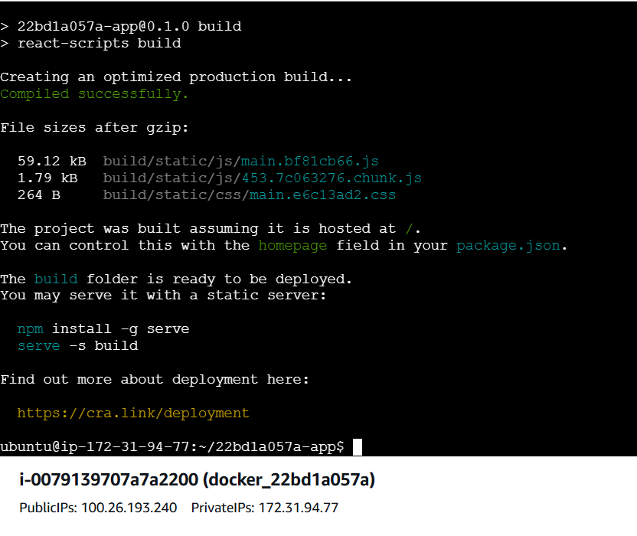

- This generates build/ folder.
PART 2: Dockerize React App on EC2
Step 1: Install Docker
- sudo apt update
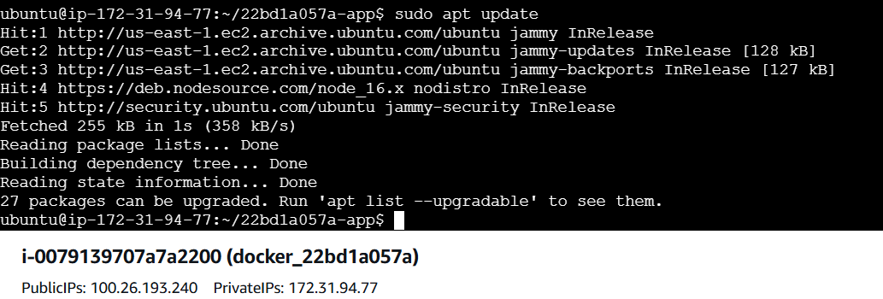
- sudo apt install docker.io -y
- sudo systemctl start docker
- sudo systemctl enable docker
- docker –version
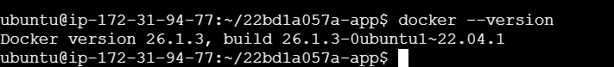
Step 2: Add Dockerfile (in project root — NOT src/)
- nano Dockerfile
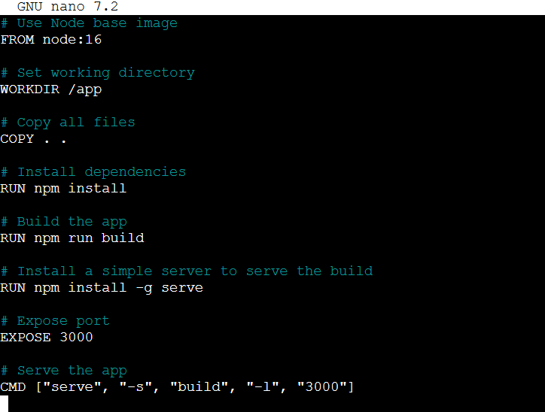
Step 3: Create .dockerignore
- nano .dockerignore

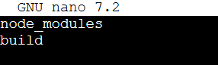
PART 3: Build & Run Docker Container
Step 1: Build Docker Image
- sudo docker build -t 22bd1a057a-app .
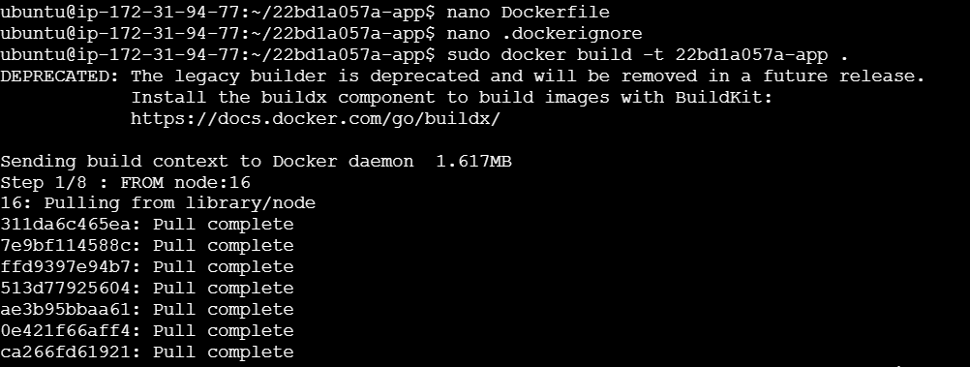

Step 2: Run the Docker Container
- sudo docker run -d -p 3000:3000 22bd1a057a-app
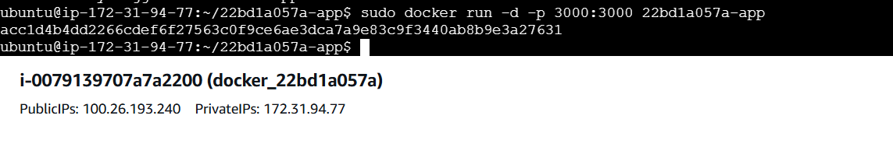

Step 3: Access from Browser
- Visit: http://<your-ec2-ip>:3000
- You should see:
  - Input: Enter your name
  - Button: On click → Shows welcome message with your name.
